In this practice, you format graphics (illustrations) according to the guidelines you read about in the onlime textbook. If necessary, review these chapters: graphics and cross-references—in particular, “Explanatory Phrasing in Cross-References.”
For each of the graphics below:
- Add a title, making sure of the standard location.
- Add a source indicator based on the bibliographic note.
- Add a paragraph above the graphic that contains an explanatory cross-reference to the graphic.
- Add a paragraph below the graphic with the heading “Information Sources,” a source number, and the bibliographic reference.
- Name your file with some part of your name and _graphics for example, davidmc_graphics.docx (or whichever extension your app uses).
- Send this practice file by e-mail attachment to your instructor at davidm@austincc.edu.
- Send this practice file by e-mail attachment to your instructor at davidm@austincc.edu.

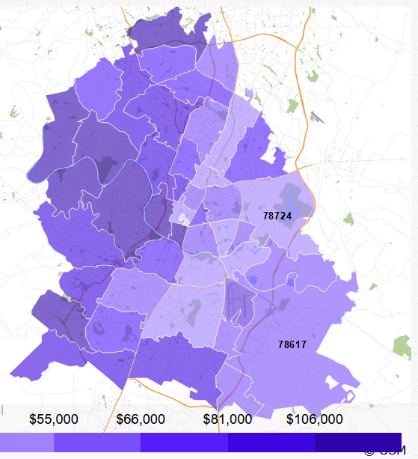
Format notes: the areas of Austin with higher incomes are in the western portions of the city; lower incomes to the east. Source: Brightwheel. 2023 Cost Guide for Austin Daycares and Preschools. December 23, 2022. mybrightwheel.com/search/l/guides/cost-guide-austin-tx-daycares-preschools [Accessed December 1, 2023]

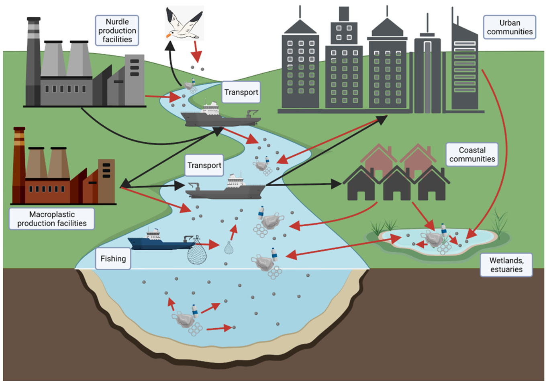
Format note: this infographic shows how how microplastics enter and move throughout the environment. Source: Douglas, Erin. “Texas Regulators Proposed Cracking down on Harmful Plastic ‘Nurdles’ - and Then Changed Their Minds.” The Texas Tribune, The Texas Tribune, 7 Sept. 2022, www.texastribune.org/2022/09/06/tceq-microplastics-nurdle-pollution/#:~:text=Volunteers%20have%20found%20that%20the,%25%20preventable%2C%E2%80%9D%20he%20said.
Be sure to look up the meaning of “nurdle.”

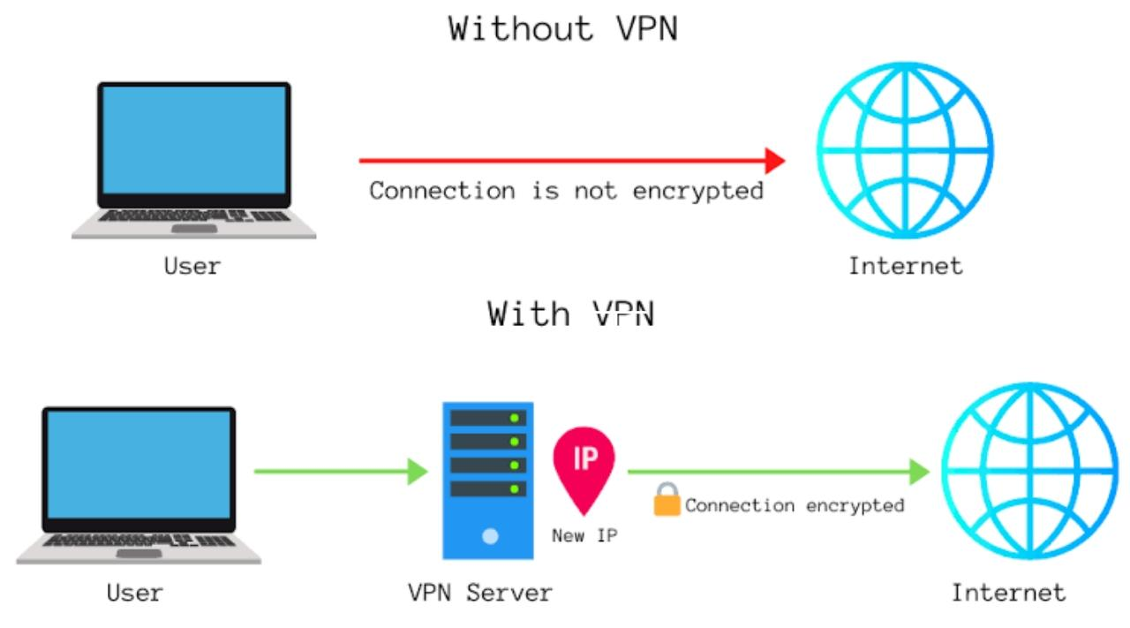
Formatting note: Source: Rist, Oliver. "4 Reasons Your Business Should Use a VPN Service" PCMag, 12 Nov 2018, https://www.pcmag.com/news/4-reasons-your-business-should-use-a-vpn-service

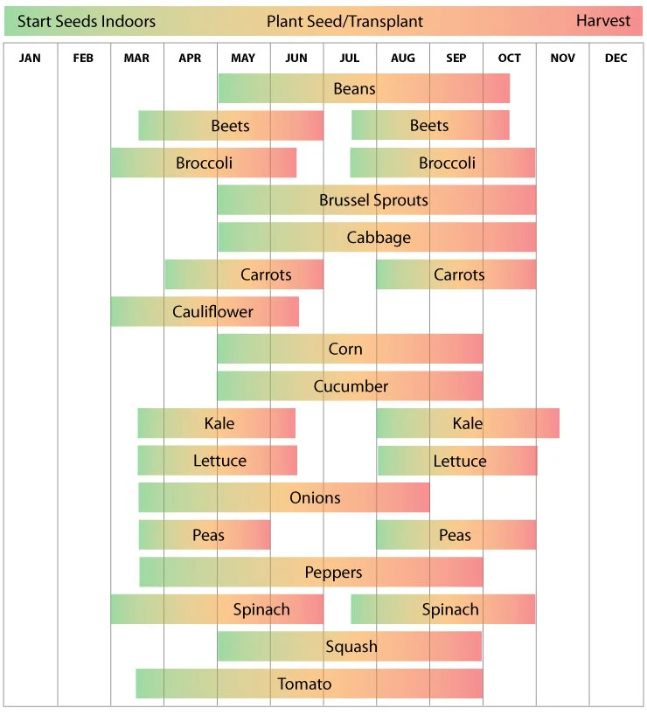
Formatting note: Source: Urban Farmer, "Texas: Vegetable Planting Calender," Urban Farmer LLC, 2021. [Online]. Available: https://www.ufseeds.com/texas-vegetable-planting-calendar.html. [Accessed 5 May 2022].

