A Beginner's Guide to Eudora Lite
for Windows
This is a beginner's guide to using Eudora Lite 1.5.4 for Windows 95. It covers everything you need to know to start using Eudora to send and receive e-mail, including: (1) essential settings and program configuration; (2) the basic tasks involved in composing and sending e-mail, receiving and reading messages, as well as what to do with them when your done; and (3) how to find more information about using Eudora once you've learned the basics.
Eudora Lite is freeware (software which may be used at no cost) that offers a set of tools and basic e-mail utilities for managing electronic mail messages. The program employs standard Windows graphical interface elements, so that anyone familiar with the Windows environment should find Eudora easy to navigate. The application is configured to access a specific account on a POP server—a computer connected to a network or the Internet running software that sends, receives and stores e-mail. Eudora then acts as the communication agent between the remote server and the local computer—sending and receiving mail messages to and from the POP account. Finally, Eudora offers a set of utilities for manipulating and organizing messages stored on the local system.
To use this guide you need only be familiar with the basics of mouse operation and navigating standard Windows interface objects such as menus, windows, dialog boxes, and toolbars.

Eudora Setup
Before you can begin using Eudora, you must make sure you have the right equipment and configure Eudora.
Getting started. To use these instructions, you'll need the following:
- An IBM PC-compatible computer running under Windows 95.
- A copy of the Eudora Lite application installed and currently running on your machine.
- Internet access with a POP3 e-mail account.
Note: If you are not sure what kind of account you have, contact your Internet Service Provider. POP simply refers to the type of software used on the remote server where your e-mail is received and stored. Most e-mail accounts today use POP3 software.
Before you can use Eudora for completing basic e-mail tasks, you must tell the program a few things about yourself and your account. If Eudora is not running, you should start it now.
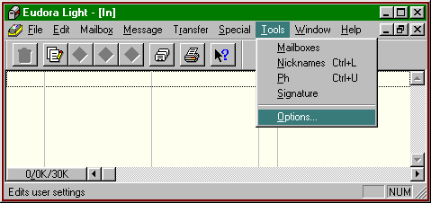
Figure 1: Tools Menu.
Configuring the program. Eudora needs very little information before you can begin using it to send and receive e-mail. You need only:
- Open the Tools menu and select Options as shown in Figure 1. Eudora opens a dialog box with several option categories.
- Choose the Getting Started icon in the Categories column.
- Enter your POP Account in the space provided.
Note: Your POP Account is your username followed by the "@" symbol, and the name of your e-mail server. For example, if your username is "jdoe" and your service provider is "the.mail.com", you should enter "jdoe@the.mail.com" in the POP Account space. This is your e-mail address.
- Enter your actual name in the Real Name space. This name identifies you to your e-mail recipients.
- Make sure the Winsock (Network, PPP, SLIP) button is checked.
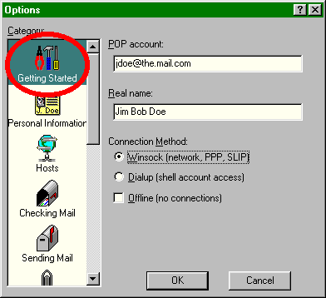
Figure 2: Basic Configuration Settings
When its settings resemble those shown in Figure 2, Eudora is ready to communicate with your e-mail server.

Basic E-Mail Tasks
Eudora is simply a program for managing e-mail. The following sections cover the basic steps for composing, sending, receiving, reading, and managing your messages.
Composing and sending messages. Eudora provides a convenient facility for creating new e-mail messages, which are then sent out to the network. As shown in Figure 3, the steps are simple:
- Open the Message menu and select New Message. The program will open a window in which you can address and compose the message.
- Enter the e-mail address of your recipient in the To: field. Eudora always places the cursor in this position each time a new message window is opened.
Note: You can send mail to yourself as a test. Simpy enter your own e-mail address.
- Tab down to, or click on the Subject line. Type a subject for your message.
- Tab down three times, or click on the body portion of the message box. Enter your message here.
- Send the message when it is complete. Simply click on the Send button in the toolbar at the top of the message window. Eudora will contact your server and submit a copy of the message to be sent out on the Internet or network.
Warning: Be certain your message is ready for the rest of the world—you can't get it back once you press the Send button.
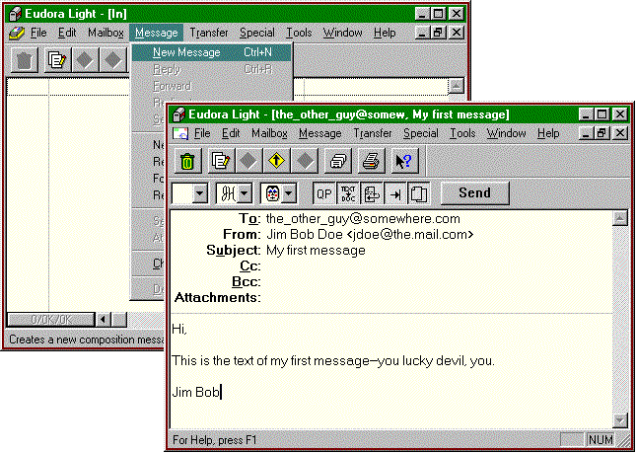
Figure 3: New Message Menu and Window.
Receiving and reading messages. You can use Eudora to check your POP account for mail, copy new messages to your machine, and then read them:
- Open the File menu and select Check Mail.
- Enter your password when Eudora prompts for it. The program will establish contact with your server and check for new mail on the account. If messages are present, Eudora will notify you and copy the e-mail to your In box to be read.
Note: If you do not know your password, or have never defined one, check the documentation that came with your account, or contact your Service Provider for help.
- Select a new message to be read. Figure 4a shows a listing of new messages in the In box. Simply double-click on any meassage to read it. The program will open a message window which contains the body of the mail. (Figure 4b)
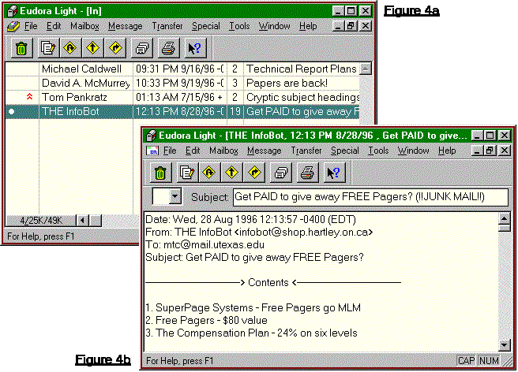
Figures 4a & 4b: Reading Messages.
Saving messages. Once a message has been read, you will want to either keep or discard it in order to move on to other messages. If you want to retain the mail:
- Click on the close box associated with the message window. This will close the message, and retain the mail on the In box list.
Warning: Clicking the close box in the far upper right-hand corner of the program window will cause Eudora to quit.
Deleting messages. There are various ways of discarding mail once it is no longer needed. If you wish to delete the message after reading it, you should:
- From within the message window, click on the Trash Icon in the toolbar or open the Message menu and select Delete.
OR
- From the In box list of mail, highlight the message by clicking on it, and then click on the Trash Icon in the toolbar or open the Message menu and select Delete.
Figure 5 labels all items necessary for basic message management. Notice that the highlighted message from "The InfoBot" in the In box will be deleted by clicking the trash icon
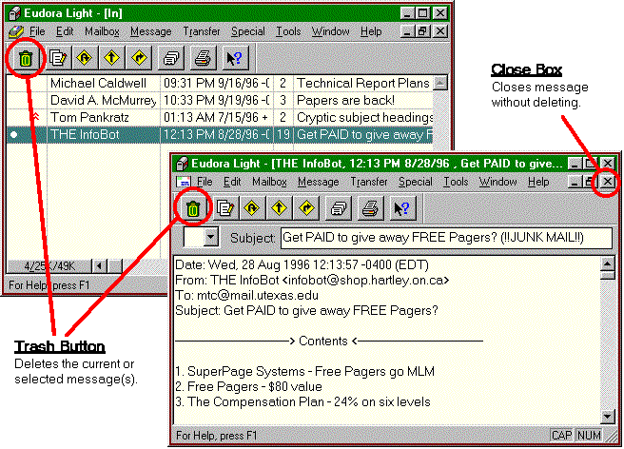
Figure 5: Basic Message Management Tools.

Getting More Information
You now have the basic skills needed to send and receive e-mail with the Eudora Lite application. In addition to the tasks you just completed, Eudora has many useful tools to help organize and facilitate the managment of mail messages. The program is both easy to use, and highly customizable.
Eudora provides two basic means of learning more about its features from within the program: (1) Context-sensitive help, and (2) the Help menu.
Using the context-sensitive help feature. Eudora can often provide brief tips or explanations based on a click of the mouse. The two methods of getting this kind of help are:
- Place and hold the mouse pointer over object if whose function you are unsure. If help is available, a small box containing the item's name will appear near the pointer. A short explanation of the function will also appear in the Status Bar.
OR
- Click on the Context Help button in the toolbar. A question mark will appear beside the mouse pointer. Next, click on any object about which you have questions. If help is available, Eudora will display a box containing more in-depth information about the item.
Note: This method, unlike the above, often extends to windows and menu items in addition to buttons.
Accessing the Help screen. For a thorough discussion of utilizing Eudora's features:
- Click the "How to. . ." topics in the application's Help screen.
- Open the Help menus and select Topics. You will see the Eudora Help topic screen.
- Double-click on the "How To. . ." topic. The menu will expand to show additional choices.
- Choose a topic by double-clicking the icon. Each topic contains two or three help documents as shown in figure 6.
Note: A good place to begin is with the "Respond To Incoming Mail" topic.
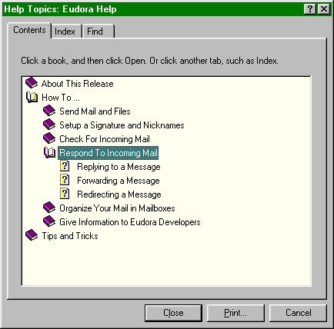
Figure 6: Eudora Help Topics

