Using PowerPoint Microsoft 365 to Create and Insert an Animated GIF into a Document or Presentation

Nicole Guthrie
July 3, 2022

Everyone has seen a PowerPoint presentation with bullet points and pictures flying in with the touch of a button. When creating instructions for others, it is helpful to have a visual of how the animation works. Using an animated GIF is a simple way to demonstrate this technique. These instructions will provide you the tools to export an animated GIF into any document or presentation.

Tools Needed

- Computer with PowerPoint, preferably with Microsoft 365
- Information you want to make into an animated GIF
- Document where an animated GIF is desired.

When to Add a GIF

Using a GIF appropriately is essential to obtain the maximum effect. An animated GIF allows you:

- Demonstrate the appearance of animation in PowerPoint presentation
- To visually teach a procedure

Note: It is most effective when it is not used everywhere.

How to Add Animation that an Animated GIF will Demonstrate.

Creating a GIF is a simple process, but the extra step can make a document or presentation seem more professional. Follow these steps:
- Open the PowerPoint slide you wish to animate.
- Create a bulleted list.
- Select one or all the bullet points.
- Click the Animation Tab (see Figure 1).
Figure 1: Here is a picture of the tool bar in PowerPoint 365. When you select Animations, you will see the various options listed. Source: Screenshot on Microsoft PowerPoint 365. Accessed June 7, 2022.

- Select an animation style. Try “Fly In” or “Appear”.

Note: You will see a small pink box appear with the #1 next to the text or picture you selected. This is telling you it will be the first thing to animate on this page.

- If you select more than one bullet point, it will automatically animate them all in the order they are written on the slide. For example, see Figure 2.
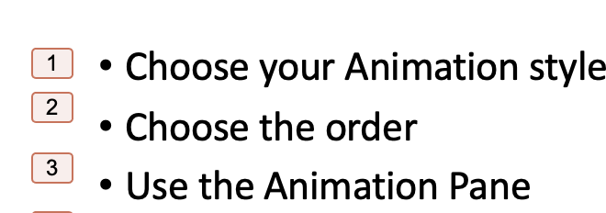
Figure 2: As you can see the bullet points were numbered 1 through 3 when selected and an animation style was chosen. Source: Screenshot on Microsoft PowerPoint 365. Accessed June 7, 2022.

How to Activate the Added Animation

Now that you have added animation to a bullet point. You need to know how to edit the animations as well. To activate your animation, follow these steps:
- Select the Animation Pane.
- Select Timing. Timing allows you to decide when you want your animation to appear.
  - Select how you want to Start the animation. There are three options:
        - On Click
        - With Previous
        - After Previous
  - Select Duration
    - This is how fast the text or picture appears.
  - Select Delay
    - This is used if you want there to be a delay after you have clicked for the text to appear.
  - Select Repeat
    - Only used if you want the text or picture to repeat over and over.
- Select Triggers. Triggers allows you to animate text or an object within an animation sequence.
- For example: You have 4 bullet points set to go On Click and you want to circle one of them. You would use trigger for the circle.
- You can select to start the effect in two ways:
  - As part of a click sequence
  - On click.
- Select Text Animations. Text Animations allows you to have your text come up in three different ways.
  - Letter by letter
  - Word by word
  - Bullet point by bullet point

Note: You may not notice the Letter by Letter working if the Duration in the Timing setting is set to very fast.

How to Test Your Animation

Now it is time to test your animation and see if it works the way you hope. Follow these steps:
- Select Slide Show
- Select one of two options:
  - Play from Start
  - Play from Current Slide
- When your slide show appears, begin clicking through and watch what your extra effort has created.

How to Export an Animated GIF

Now that you have created an animated slide, it is time to export the slide as an animated GIF. You are then able to insert the animated GIF in a document or presentation of your choice.
      - Select the slide you wish to turn into an animated GIF.
      - Select File from the top toolbar.
      - Select Export.
      - Select Animated GIF (see Figure 3). Then check the following information:

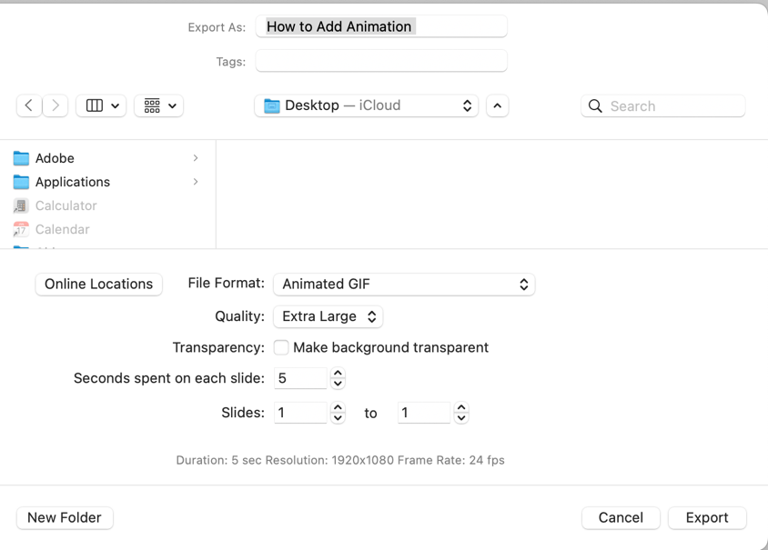

Figure 3: Here is an example of the of the options when exporting an animated GIF. Source: Screenshot on Microsoft PowerPoint 365. Accessed July 3, 2022.

        - Select where you want to save the animated GIF. Currently it is set to save it on the Desktop.
        - Check that File Format is Animated GIF.
        - Select Quality (Size)
        - Transparency: Select whether you would like the background to be transparent.
        - Seconds spent on each slide: This option is only used when animating multiple slides.
        - Slides: Select which slide you are exporting as an animated GIF.
      - Select Export in the bottom right corner.

You have now exported your animated GIF to your desired location. You can simply insert the GIF into any document or presentation you would like. Here is an example of an animated GIF created in PowerPoint, exported to a Desktop and then inserted into a Word document.

Note to Instructor: These instructions are intended for anyone looking to use PowerPoint export a GIF for another document. This could be used from the classroom to the boardroom. They have a basic knowledge of how to create a PowerPoint slide, add bullet points, photos, or graphics, choose slide layouts and export.

